Constraints

🌟 Definition
# Source: AI Source: Provided by: [Data Path: Persons Table -> ID Column: 1, Name_En Column: Motasem Essam] -> From: [ChatGPT] on [6/10/2026]
A Constraint is a rule enforced on data in a database to ensure the data remains accurate, valid, consistent, and reliable.
Constraints restrict what data can be stored in tables.

🎯 Purpose
# Source: AI Source: Provided by: [Data Path: Persons Table -> ID Column: 1, Name_En Column: Motasem Essam] -> From: [ChatGPT] on [6/10/2026]
Constraints help:
- Maintain data integrity
- Prevent invalid data
- Enforce business rules
- Ensure consistency
- Reduce data errors

🧠 Simple Example
# Source: AI Source: Provided by: [Data Path: Persons Table -> ID Column: 1, Name_En Column: Motasem Essam] -> From: [ChatGPT] on [6/10/2026]
Suppose a Customer table contains:
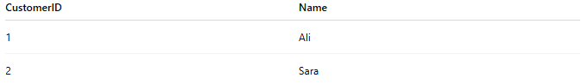
CustomerID | Name
1 | Ali
2 | Sara
If CustomerID must be unique, the database should reject:
CustomerID | Name
1 | Ahmed
because CustomerID 1 already exists.
This rule is enforced by a constraint.

🔢 Main Types of Constraints

1. 🔑 Primary Key Constraint
# Source: AI Source: Provided by: [Data Path: Persons Table -> ID Column: 1, Name_En Column: Motasem Essam] -> From: [ChatGPT] on [6/10/2026]
🌟 Purpose
Uniquely identifies each row in a table.
Rules:
- Must be unique
- Cannot be NULL

Example
Table:
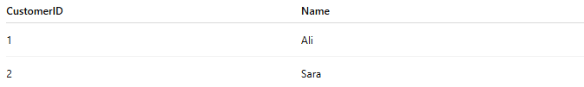
CustomerID | Name
1 | Ali
2 | Sara
CustomerID is the Primary Key.

SQL Example
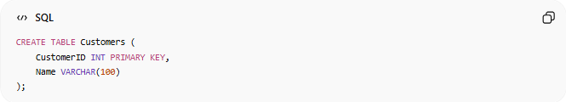
CREATE TABLE Customers (
CustomerID INT PRIMARY KEY,
Name VARCHAR(100)
);

2. 🚫 NOT NULL Constraint
# Source: AI Source: Provided by: [Data Path: Persons Table -> ID Column: 1, Name_En Column: Motasem Essam] -> From: [ChatGPT] on [6/10/2026]
🌟 Purpose
Ensures a column always contains a value.

Example
Valid:
CustomerID | Name
1 | Ali
Invalid:
CustomerID | Name
2 | NULL

SQL Example
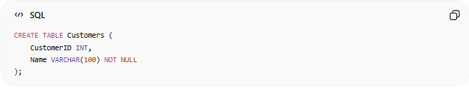
CREATE TABLE Customers (
CustomerID INT,
Name VARCHAR(100) NOT NULL
);

3. 🔁 UNIQUE Constraint
# Source: AI Source: Provided by: [Data Path: Persons Table -> ID Column: 1, Name_En Column: Motasem Essam] -> From: [ChatGPT] on [6/10/2026]
🌟 Purpose
Prevents duplicate values.

Example
Email addresses must be unique.
Valid:
Email
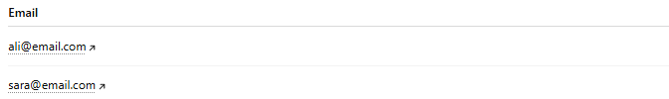
ali@email.com
sara@email.com
Invalid:
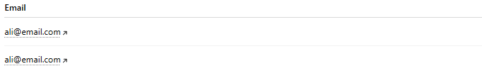
Email
ali@email.com
ali@email.com

SQL Example
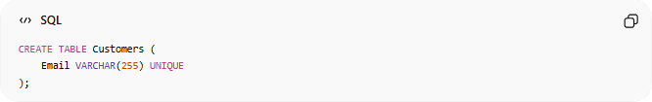
CREATE TABLE Customers (
Email VARCHAR(255) UNIQUE
);

4. 🔗 Foreign Key Constraint
# Source: AI Source: Provided by: [Data Path: Persons Table -> ID Column: 1, Name_En Column: Motasem Essam] -> From: [ChatGPT] on [6/10/2026]
🌟 Purpose
Maintains relationships between tables.

Example
Customers Table:
CustomerID | Name
1 | Ali
Orders Table:
OrderID | CustomerID
101 | 1
The CustomerID in Orders must exist in Customers.

SQL Example
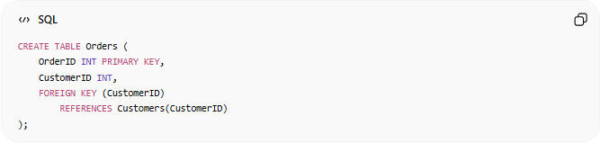
CREATE TABLE Orders (
OrderID INT PRIMARY KEY,
CustomerID INT,
FOREIGN KEY (CustomerID)
REFERENCES Customers(CustomerID)
);

5. ✅ CHECK Constraint
# Source: AI Source: Provided by: [Data Path: Persons Table -> ID Column: 1, Name_En Column: Motasem Essam] -> From: [ChatGPT] on [6/10/2026]
🌟 Purpose
Ensures values meet a condition.

Example
Age must be 18 or older.
Valid:
Age
20
Invalid:
Age
15

SQL Example
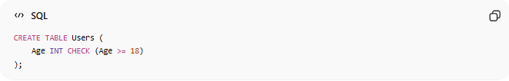
CREATE TABLE Users (
Age INT CHECK (Age >= 18)
);

6. 🎯 DEFAULT Constraint
# Source: AI Source: Provided by: [Data Path: Persons Table -> ID Column: 1, Name_En Column: Motasem Essam] -> From: [ChatGPT] on [6/10/2026]
🌟 Purpose
Provides a default value if none is supplied.

Example
Status column defaults to:
Active

SQL Example
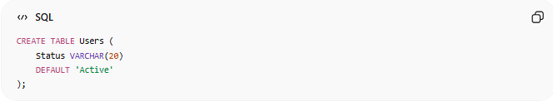
CREATE TABLE Users (
Status VARCHAR(20)
DEFAULT 'Active'
);

Result
If no value is provided:
UserID | Status
1 | Active

📊 Constraint Summary
# Source: AI Source: Provided by: [Data Path: Persons Table -> ID Column: 1, Name_En Column: Motasem Essam] -> From: [ChatGPT] on [6/10/2026]
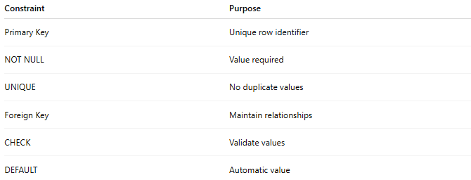
Constraint | Purpose
Primary Key | Unique row identifier
NOT NULL | Value required
UNIQUE | No duplicate values
Foreign Key | Maintain relationships
CHECK | Validate values
DEFAULT | Automatic value

🗄️ Example Table with Multiple Constraints
# Source: AI Source: Provided by: [Data Path: Persons Table -> ID Column: 1, Name_En Column: Motasem Essam] -> From: [ChatGPT] on [6/10/2026]
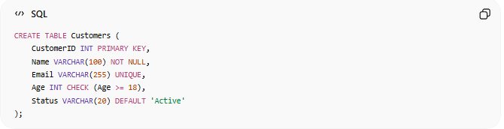
CREATE TABLE Customers (
CustomerID INT PRIMARY KEY,
Name VARCHAR(100) NOT NULL,
Email VARCHAR(255) UNIQUE,
Age INT CHECK (Age >= 18),
Status VARCHAR(20) DEFAULT 'Active'
);

🌍 Real-World Examples
# Source: AI Source: Provided by: [Data Path: Persons Table -> ID Column: 1, Name_En Column: Motasem Essam] -> From: [ChatGPT] on [6/10/2026]
Banking
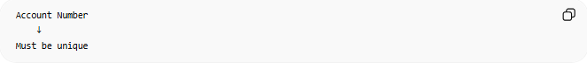
Account Number
↓
Must be unique

E-Commerce
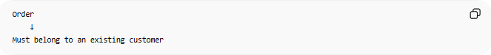
Order
↓
Must belong to an existing customer
(Foreign Key)

School System
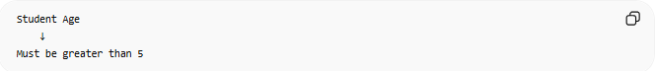
Student Age
↓
Must be greater than 5
(CHECK)

User Registration
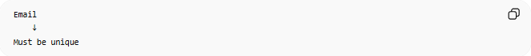
Email
↓
Must be unique
(UNIQUE)

⚠️ Constraints vs Relationships
# Source: AI Source: Provided by: [Data Path: Persons Table -> ID Column: 1, Name_En Column: Motasem Essam] -> From: [ChatGPT] on [6/10/2026]
Relationship
Customer places Order
Describes how entities are connected.

Constraint
Order.CustomerID
must exist in Customer table
Enforces a rule on that connection.

🧠 Simple Analogy
# Source: AI Source: Provided by: [Data Path: Persons Table -> ID Column: 1, Name_En Column: Motasem Essam] -> From: [ChatGPT] on [6/10/2026]
Think of a database as a school.
- Entities = Students, Teachers, Courses
- Attributes = Name, Age, Subject
- Relationships = Students enroll in Courses
- Constraints = School rules
Examples:
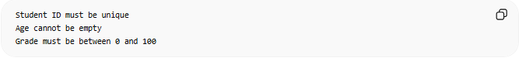
Student ID must be unique
Age cannot be empty
Grade must be between 0 and 100
These rules are constraints.

🧭 Summary
# Source: AI Source: Provided by: [Data Path: Persons Table -> ID Column: 1, Name_En Column: Motasem Essam] -> From: [ChatGPT] on [6/10/2026]
A Constraint is a rule that controls what data can be stored in a database. Constraints enforce data integrity and consistency by ensuring values are valid, unique, required, correctly related, or automatically assigned when needed.

